PL/SQL PROGRAMMING

Exercise 1: Control Structures

Code:

DECLARE

   num NUMBER := -7;

BEGIN

   IF num > 0 THEN

      DBMS_OUTPUT.PUT_LINE('The number is Positive.');

   ELSIF num < 0 THEN

      DBMS_OUTPUT.PUT_LINE('The number is Negative.');

   ELSE

      DBMS_OUTPUT.PUT_LINE('The number is Zero.');

   END IF;

END;

/

Output:

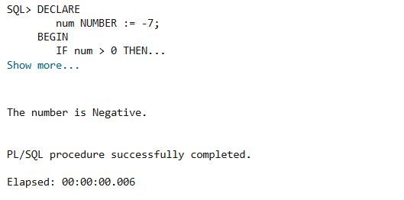

Exercise 3: Stored Procedures

Code:

DECLARE

   num NUMBER := 13;

BEGIN

   IF MOD(num, 2) = 0 THEN

      DBMS_OUTPUT.PUT_LINE(num || ' is Even.');

   ELSE

      DBMS_OUTPUT.PUT_LINE(num || ' is Odd.');

   END IF;

END;

/

Output:

